Data Visual – Covid

# Screenshot

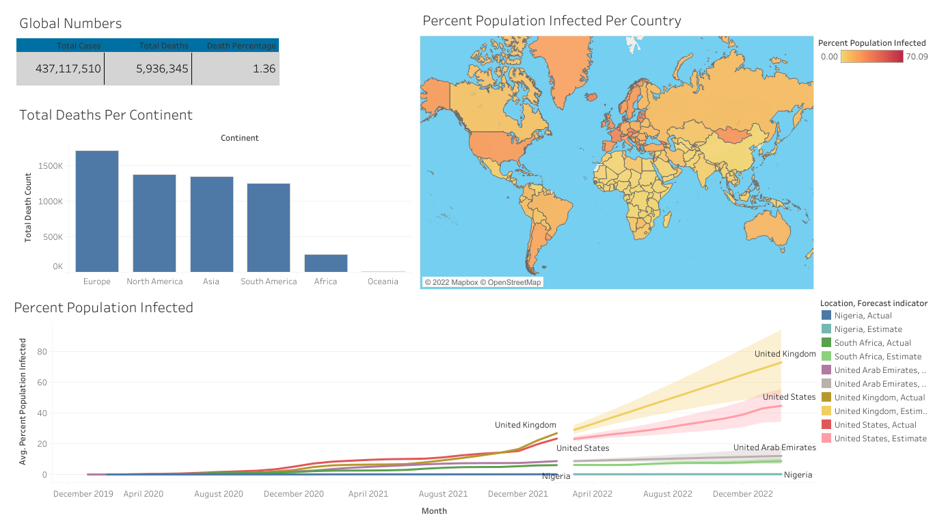

<https://public.tableau.com/views/DataVisualization-Covid/Dashboard2?:language=en-US&:display_count=n&:origin=viz_share_link>